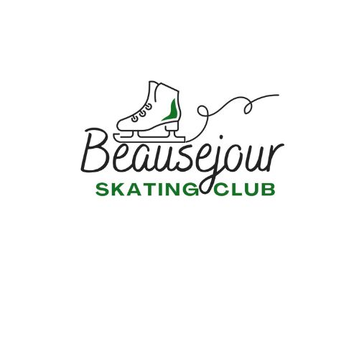

2025-2026

STARSKATE HANDBOOK

 Beausejour Skating Club



[This Photo](https://en.wikipedia.org/wiki/File:Instagram_logo_2016.svg) by Unknown Author is licensed under [CC BY-SA](https://creativecommons.org/licenses/by-sa/3.0/)

<https://beausejourskatingclub.uplifterinc.com/>

Email: [beausejourskatingclub@gmail.com](mailto:beausejourskatingclub@gmail.com)

**COACHING STAFF**

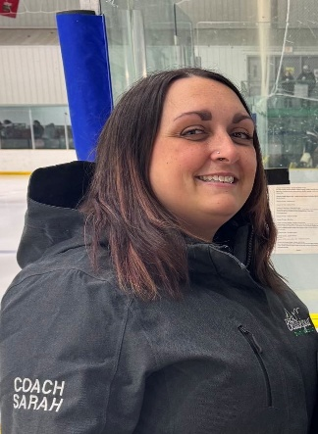**SARAH MURKIN-DEBUCKELAERE**

**Head Professional Coach**

$9.00 per 15 minute lesson.

Coach Sarah has been coaching for 22 years. She is a Regional NCCP Coach and boasts her CanPower certification. She has been coaching StarSkate with Beausejour Skating Club for over 15 years. She co-coaches our StarSkate group, as well as offers private lessons.

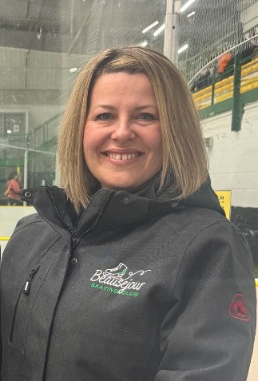**SYBIL CARELLO**

**Professional Coach**

$9.00 per 15 minute lesson.

Coach Sybil has been coaching for 21 years. She is a Provincial NCCP Coach and boasts her CanPower certification. She has been coaching StarSkate with BSC for 10 years. She co-coaches our StarSkate group, as well as offers private lessons.

**Coaching**

All of our Skate Canada Programs are coached by NCCP Certified Coaches. Our Club coaches this year will Sarah and Sybil who coach STARSkate group and offer private lessons.

**Coaching Privileges**

The BSC Board of Directors authorizes the coach’s ice privileges and no coach can offer services at the club without approval. Such approval may be refused or revoked if the coaches violate Skate Canada rules and/or their conduct is contrary to club policies or brings into disrepute the image of the club.

**StarSkate Program Times**

Friday Group 5:00-6:00 pm

Private 6-7:15 p.m.

Sunday Private 9:30-10:30

Group 11:15-12:45

**Please contact our club if you have a child interested in figure skating as there are many options available!**

**CLUB RULES AND EXPECTATIONS**

Our club keeps the safety of all our members – skaters, coaches, parents and board members – a top priority. Our rules and expectations exist to ensure that your child and all members of Beausejour Skating Club can safely enjoy the club’s skating programs in a fun and respectful environment.

**CLUB RESPONSIBILITIES** (See Skate Canada ‘s Club Code of Ethics for more information.) 1. Conduct a variety of skating programs at the skill and age levels appropriate to the club’s membership.

2. Provide professional coaches to teach the programs offered in group and/or private lessons.

3. As required, conduct Skate Canada tests in accordance with Skate Canada rules.

4. As required, conduct competitions for the various skill and age levels of the membership. 5. Conduct club business according to the club’s constitution and bylaws and the rules of Skate Canada.

6. Liaison with the Skate Canada National Office, Section and the community.

7. Ensure the amateur status of skaters is protected

**COACH RESPONSIBILITIES**

1. Coaches have the fundamental responsibility to promote skating and to coach to the best of their ability.

2. Coaches are responsible to the skaters ‐ not only as athletes but as individuals who are developing values and beliefs that will last a life time.

3. Coaches must respect another coach’s teaching methods, techniques and/or opinions.

**SKATER RESPONSIBILITIES**

1. Courtesy and respect must be demonstrated to all individuals – skaters, coaches, parents, and rink attendants.

2. Skaters should be on time for all skating sessions and lesson times – whether group, private, skating skills or stroking. Coaches will not leave the ice to find their skaters.

3. If you need to speak to a coach, do so while they are off the ice. Do not interrupt lessons. 4. Appropriate skating attire should be worn.

5. Skate guards should be used when skaters leave the ice, for safety reasons.

6. Dressing rooms must be kept clean and orderly. Trash must be placed in bins provided. 7. Skaters should keep safety in mind at all times:

a. Get up quickly after falling down

b. Look in the direction of travel when skating backwards

c. No pushing, playing tag or bumping into others or the boards

d. No gum or candy on the ice

e. Advise club and/or coaches of any special medical conditions

**CLUB RULES**

1. Fees must be paid prior to the commencement of the skating session.

2. All refund requests must be submitted to the Club Executive in writing and adhere to the refund policy outlined in detail on our website.

3. Proper skating attire should be worn by all skaters. Please see the section regarding clothing for details.

4. CanSkaters up to and including Stage 5 MUST wear a CSA-approved hockey helmet as per Skate Canada’s Helmet Use Policy.

5. No eating or chewing gum while on the ice. Please make sure that your child does not have anything in their mouth before going on to the ice.

6. Coaches are in charge of all skaters while on the ice.

7. It is important that an adult remain in charge of your skater. If this is not going to be yourself, please indicate to the Club/CanSkate Coordinator who will be responsible for your child in case of emergency.

8. Parents who wish to discuss their child’s progress with the coach must do so after sessions or when coaches are off the ice. Please do not interrupt program time.

9. If you have a concern about a program assistant, please talk to a Coach or a member of the Club Board.

10. If you have any concerns, comments, or suggestions please direct them to the Board of Directors. If you wish this concern to be discussed by the entire Board at a meeting, please put it in writing and direct it to the President.

11. Dressing rooms must be kept clean.

12. Please check the whiteboard when you come to the rink to find out which dressing room is assigned to your skater.

13. Skaters are allowed to leave the ice to use the washrooms or warm up if necessary but must ask a coach prior to leaving the ice.

14. Parents are not allowed on the ice at any time due to insurance reasons. If you need to take your child off the ice, please get the attention of one of the coaches or program assistants. Please do not go on the ice.

15. No skater is to be on the ice at the same time as the Zamboni.

**StarSkate Program**

For over a century, Skate Canada has been turning passion into podiums by perfecting its figure skating program and nurturing generations of Olympic and world champions. Today, our offering is divided into two levels and five disciplines.

**STAR 1-5**

Led by NCCP-certified Skate Canada coaches, the STAR 1-5 curriculum is Canada’s premier figure skating program. It lays the groundwork for future champions in singles, pairs, ice dance, and synchronized skating by introducing participants to all the figure skating essentials.

**STAR 6-Gold** is an assessment and event framework program designed for skaters who have completed the STAR 1-5 curriculum. It pushes your skills to the next level, building on what you’ve already learned while introducing exciting advanced figure skating elements.

**StarSkate Group** - This program is for skaters who have advanced from the CanSkate program and who are continuing their skating journey in the Skate Canada STAR program. * Group STARSkate is training with two coaches as a group for the entire session, and coaching fees are included in the price.

\*\***Private STARskate** fees are ICE ONLY and coaching fees are billed by and paid directly to the coach. Coaching for private ice time must be arranged directly with the coach and is dependent on their availability. Should your skater be interested in private lessons, please email the coach directly (email address provided in handbook) to discuss. **

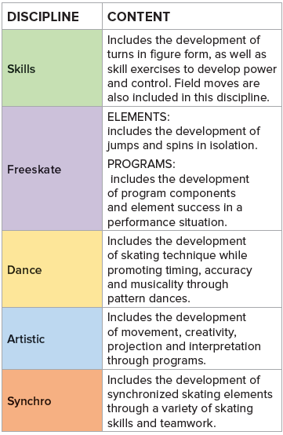**STAR 1-5 CONTENT**

Star 1-5 is designed to introduce skaters to five disciplines in figure skating. Skaters will learn the basics for each discipline that will serve as a foundation for continued growth in all areas of figure skating. The disciplines are: Skills, Freeskate, Dance, Artistic and Synchro.

In STAR 1-5, many elements will be repeated to allow coaches the opportunity to introduce technique, develop the technique and finally refine the technique required for further advancement in the sport.

The STAR 1-5 program contains an assessment structure that guides development. The next chart shows a list of all content that is included in the STAR 1-5 assessment pathway.

**Note for Freeskate and Artistic Programs:**

Freeskate: As the skill of performance and music interpretation is developing, the freeskate program has integrated assessment criteria to match the development of the skaters with the following order of program components:

STAR 2: Skating Skills and Performance

STAR 3: Skating Skills, Performance, and Interpretation

STAR 4: Skating Skills, Performance, and Interpretation

STAR 5: Skating Skills, Performance, Interpretation and Transitions

Composition will appear on assessments at the STAR 6 level and higher.

**Artistic: There is only one artistic program within the STAR 1-5 assessment structure.**

STAR 5 Artistic includes all program components.

STAR 5: Skating Skills, Performance, Interpretation, Transitions and Composition

Exposing skaters to all 5 disciplines will ensure skaters will develop a well-rounded skill

repertoire that will serve as a foundation for acceleration in our sport. Skaters may move

through the STAR assessment structure at their own pace per discipline. For example,

a skater may be working on STAR 3 Skills, STAR 1 Dance, and STAR 2 FreeSkate.

Assessments may be done at any time throughout the season. Your coach will decide

when a skater is prepared for an assessment and will advise the parent/guardian when

an assessment will be done.

Depending on the level and discipline, assessments are either conducted by the

skater’s coach (must be qualified for STAR 6 - Gold) or an evaluator.

**STAR 1-5 ASSESSMENTS**

To enable maximum opportunity for skill progression and development, assessments

are designed to occur during regularly scheduled training sessions and do not require

additional ice time or coaching fees. All assessments at the STAR 1-5 level are

designed to be conducted by the skater’s coach. When a skater is ready for a test, the

Coach will assess the skater during a regularly scheduled lesson. The flexibility of

having a coach assess during lesson times eliminates having to wait for a regional or

provincial test day and potentially delaying a skater's progression.

**The cost of each assessment is 12.00, payable to the club at the time of the assessment.**

**STAR 6** – Gold assessments are organized by the coaches and the club’s Assessment Coordinator in an effort to provide an assessment format that best suits the situation and the skater.

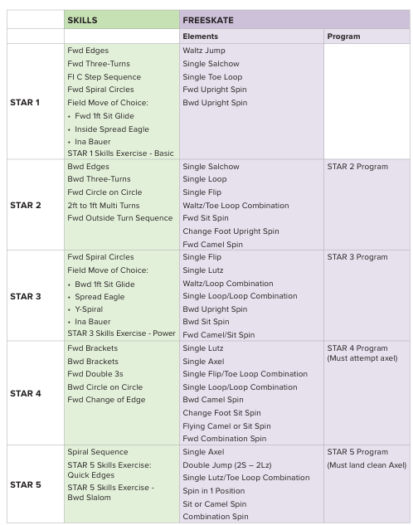

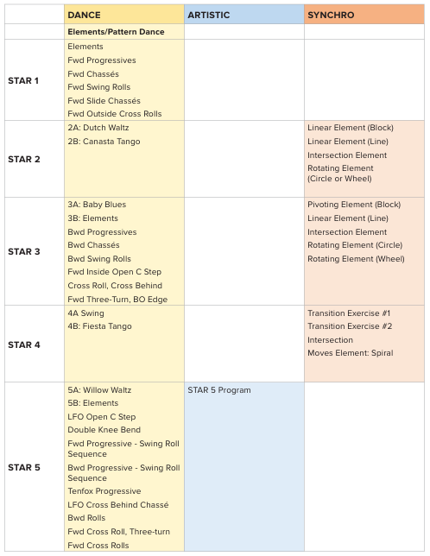

**ASSESSMENT ATTIRE**

Regular practice attire is acceptable for STAR 1 and 2 assessments.

Performance attire is recommended for assessments higher than STAR 2. Gloves and

jackets may be worn for warm-up but should be removed for the assessment (if

temperatures allow). Hair should be neat and pulled back away from the face. Skates

and laces should be clean and tidy.

**COMPETITIONS**

Competitions are completely optional, but highly encouraged by our coaches. In the

past, our skaters have attended several competitions and have had lots of fun!

Competitions are successful weekends full of excitement, nerves, team bonding, and

learning for all skaters. Each skater contributes to a collection of medals, ribbons, and

personal accomplishments that make our coaches and club very proud each season.

**WHY COMPETITIONS?**

**Performing:** Competition exposes skaters to the spotlight. Being comfortable

performing solo in front of a crowd is an important life skill that can be applied to other

aspects of life such as school and work. This skill is also required for skating tests when

being evaluated in front of a judge at test days.

**Motivation:** Competition keeps skaters motivated. Skaters work towards a given task

(program) with a deadline (competition day) and a goal in mind (to perform their best).

Most skaters practice with more determination and purpose when they know a

performance is coming up.

**Progress:** This is your skater’s chance to shine and show off the skills they’ve

accomplished throughout the season. It’s also a chance to gain feedback from an

evaluator as to how your skater is doing at their level and what they need to work on.

**Team Bonding:** Competitions are a great time for skaters to cheer on their peers and

encourage one another as they perform on the ice. Skaters have fun making posters

and showing their club pride throughout the competition. Even though figure skating is

considered an individual sport, some of the best memories and friendships are formed

between skaters at competitions.

**WHAT TO EXPECT**

STAR 1 introduces skaters to performing elements in isolation. The skaters coach will remain on the ice with them.

STAR 2&3 introduces skaters to performing elements in a choreographed program to

music. It is very similar to higher level events where there is a timed warm-up for each

group of skaters followed by performances of individual programs. Judges assess

each skater based on standards set by Skate Canada. At the conclusion of the STAR

events, each skater is presented with a report card and a ribbon corresponding to their overall assessment.

STAR 4 and up marks the entry point into competitive skating where skaters are scored

and ranked. Medals are awarded to the top 3 finishers. All competitors receive a report

card listing assessments for each element and program component as well as their

overall ranking.

**COMPETITION DATES**

Competition dates are typically announced at the beginning of the season.

Communication about upcoming competition opportunities will be communicated when

available to the coaches and club. **If you skater is interested in competing throughout the season, best practice is to email the coaches about opportunities for your skater.**

**HELPFUL COMPETITION TIPS:**

* Your skater will need to pack: Skating dress or proper competition attire, clean tights, clean skates, and extra laces, club jacket or warm up jacket, mini mitts, hair supplies, makeup (if desired).

Some extra things to consider packing, lint roller, magic eraser (for cleaning skates),

extra pair of tights, healthy snack, water bottle.

* Plan to arrive a minimum of one hour before your skaters scheduled skating time. Competitions will not wait for skaters and no makeup time is available. Please be sure you skater arrives at the rink dressed with makeup and hair done. If you plan on getting ready at the rink allow enough extra time to do so.
* When you arrive at the venue make sure to check in.
* Connect with your coach and locate your dressing room.
* Warm up and mentally prepare for your skate.
* Put your skates on at least 15 min prior to your warmup skate.
* The ice captain of the event will call groups from dressing rooms.
* Skater will proceed to the ice and their coach will guide them through their warmup and help to calm nerves.
* Each skater will participate in their order.
* After their skate and once the whole group is done, they will do the awarding for that group.
  + For Competitions a ribbon or medal presentation will take place, hosting arena will have a scheduled time for groups to receive awards.
  + Please remind skaters to be gracious in managing emotions with placement or result that they wanted or not.
  + No matter what the placements turn out to be if skaters worked hard, tried their personal best, had fun and learn that is all that's important.

**TYPICAL COMPETITION COSTS**

1. **Registration Cost –** paid at the time of registering for the competition – cost paid per registered events per skater
   1. **For guidance on which events may be best suited for your child, please talk to Coaches.**
2. **Accommodations/Travel Costs –** many competitions happen over several days and require overnight stays.
   1. **TIP:** Competition schedules do not usually come out until a few weeks before the competition and flight information is usually only the week before. Booking accommodations early ensures you have lodging for all of the potential days required.
3. **Coaching Costs –** Will be billed directly by the coaches. This will include a fee (usually 2x their private rate) for each event your skater is registered in. As per club policy, coaches mileage, lodging and meal allowance may be paid for by the club in some instances, and in other instances may be the skater’s responsibility (divided by number of skaters attending). This information will be available prior to the competition.
4. **Skating Outfit/Attire –** acceptable competition attire must be worn, as per guidelines. Price will vary – skaters are responsible to acquire their own skating attire.
   1. **TIP:** If you need assistance please reach out to Coaches or the board. Often our skaters/club may have assessed to gently loved items for lend/sale.
5. **Skates –** as per guidance outlined in Equipment and attire. Skates should be clean and presentable for competition.
   1. **TIP:** Magic Eraser or Skate Tape are good ways to make scuffed/worn skates look competition ready!

**EQUIPMENT & ATTIRE**

**FIGURE SKATES**

Figure skates are required for STARSkate.

In skating, skates are the most important piece of equipment. Purchasing appropriate

skates to suit the level of skater and your budget is of utmost importance. Providing

your child with appropriate skates will help them improve their skating more quickly and

will make their on-ice experience more enjoyable.

**Talk to your skater’s coach about the boots and blades that will be most appropriate for your skater.**

**Buying New Skates**

When purchasing new skates, it is recommended discuss your figure skaters/need and level with their coach prior to purchasing.

It is also recommended you review proper skate fit guidelines (below) to ensure your child is set up for success, and comfort.

**Buying Used Skates**

You don’t necessarily have to spend a lot of money to get a good pair of skates. There

is usually a ready market at local stores and online for second hand skates in

reasonably good condition at the beginning of the season, so keep an eye out! Do be

cautious that the blade is not so worn that it cannot be sharpened anymore.

**How the Boot Fits**

The most important consideration when buying skates is how the boot fits. This can

make the difference between frozen feet and frustration, and having fun on the ice.

Contrary to what most people think, the average skater takes a half size smaller than

their walking shoe.

Make sure:

* The boot is snug around the instep and the heel
* There isn’t much buckling of the leather around the ankle
* There is a gap of 3-4cm (1-1.5”) between the lacings and the instep
* There is enough room for the skater to wiggle their toes
* Remember to fit skates over thin socks or tights. Bulky or thick socks don’t allow

toes to breathe, causing sweaty feet that are more susceptible to the cold. Plus,

thicker socks often bunch around the ankles which can cause discomfort for the

skater.

Here’s a simple test to see if you’ve got the right fit - lace up the boot, then ask

someone to hold the blade down and see if you can lift your heel. If you can, then try a

half size smaller. A word of warning to parents - when you are buying skates for your

skater, make sure the boot gives their ankles enough support. Don’t get skates that are

several sizes too large to allow them “room to grow”.

**Breaking in New/Used Skates**

Most skate brands use a technology that allows the boot to flex and bend in the ankle

area while still being tied tight for support. However, even though the heat molding

process fits the boot to the foot, the skater will still have to physically break in the crease

area. Walking around in the skates at home, or doing squats while the skates are

properly tied, will help break in the crease area.

**Keep on Top of Changes**

When a skater’s feet grow or change shape, adjustment to the boot may be necessary.

**Care for Your Skates**

With a reasonable amount of care, a pair of skates can last a long time. Here are some

maintenance tips:

* Dry the blade after each use ensuring all snow and ice have been removed. This

includes the sole of the boot.

* Place dry blades into a cloth blade protector for storage. Do not put blades back

into the hard skate guards, as trapped water could form rust on the edges of the

blade.

* Skates should be aired out each day after practice to allow the leather to dry.

Skater’s feet sweat inside their skates. Damp leather could rot and weaken the

boot.

* Blades should always be protected by skate guards when walking to and from

the ice surface. NEVER walk on floors with unprotected blades.

* Do not sharpen skates the night before a test day or competition!

**Sharpening the Blades**

* Brand new skates should be sharpened before you use them for the first time.
* The bottom toe pick should NOT be removed. This is part of the design of figure

skates. Toe picks are needed to execute some skills and are essential to proper

balance.

* Sharpening will get rid of any nicks and/or rust that may accumulate.
* Skates should be sharpened after approximately 20-40 hours of skating,

depending on the quality of the blade.

* The type of sharpening is dependent on the skater’s preference and their skill

level.

* Talk to your coach for recommendations on where is most appropriate to get your skates sharpened.

**PRACTICE ATTIRE**

Beausejour Skating Club asks all STARSkaters to adhere to the following practice attire in

promotion of:

* a safe and positive learning environment
* healthy self-image
* respect for self and others

At the STARSkate level, a coach needs to see a skater’s body alignment to give proper

advice and feedback about technique. As such, Form-fitting clothes that stretch are

better than tight, restrictive or oversized clothes that restrict movement. Here is the

recommended attire for STARSkaters:

* All Skaters who have not passed Star 1 must wear a CSA approved hockey helmet on the ice (as per our Coaches expectations). Skate Canada mandates the use of a CSA helmet for all who have not passed CanSkate Stage 6.
* Skaters should wear athletic clothing on the ice in layers. Clothes should be

form-fitting or close to it, to allow coaches to see the body line for proper

execution of technique.

* A snug sweater or zip-up can be worn over a skating dress or shirt. Even if it is

very cold in the arena, please do not practice in heavy or bulky clothing. Baggy,

loose fitting attire is not appropriate. Layer form-fitted clothing instead!

* Gloves or mittens are acceptable during practice, but coaches may occasionally

request bare hands during lesson time for choreography purposes.

* Hair should be tied back or pulled up. It is very important that hair be away from

the face at all times. Longer hair in a bun, braid or a neat and tidy ponytail are

good choices and ensures hair doesn’t distract your skater as they spin and

jump. If your skater has bangs, make sure they are cut short or pinned back so

hair isn’t in the skater’s eyes.

* Baggy clothing (e.g. sweats, pajama pants, loose sweaters, bunny hugs, etc.),

restrictive clothing (e.g. jeans) or revealing clothing (e.g. low-rise pants, crop

tops, short shorts, transparent/see-through material, etc.) will not be tolerated.

* Small jewelry such as earrings, necklaces, and rings are allowed as long as they

do not interfere with the skater’s performance on the ice. Jewellery should be

securely fastened to the body at all times. Large, bulky, or dangling jewelry will

not be tolerated.

* Clothing must completely cover the skater’s chest, torso, and undergarments.
* Clothing must be free of inappropriate logos, phrases, and pictures.

**Any skaters who do not comply with the practice attire outlined above will be asked to leave the ice. If you are unsure about an article of clothing, please ask your coach.**

**PERFORMANCE ATTIRE**

Your skater should look and feel their best at competitions, assessments, and

ice shows. Here is the recommended attire for performances:

* Skating dresses with beige tights for girls and black pants with a dress shirt for

boys are mandatory.

* The skater should be able to practice in their outfit a few times before competition

to ensure everything looks good, stays in place, and is in no way impeding the skating.

* Skating tights should fit well and be in good condition; no pilling or rips. Packing

an extra pair in case of an unexpected tear is a good idea!

* If your skater is wearing tights that do not cover the skate boot, ensure skates

are clean and polished.

* Hair must be well secured to ensure it won’t fall out part way through a program.

Longer hair in a bun, braid or a neat and tidy ponytail are good choices and

ensures your skater’s hair doesn’t interfere with their performance. Always secure wispy hair with gel or hairspray.

* Cotton finger-mittens and a club jacket are acceptable to wear during warm-up

but should be removed before the evaluation/performance.

**PROGRAM ASSISTANTS**

To enable our club to deliver an effective program and to meet the requirements set out

by Skate Canada, we require the help of Program Assistants to assist our CanSkate

members on the ice.

Program Assistants consist of STARSkaters and/or former Skate Canada members who

volunteer their time both on and off the ice to assist our coaches in delivering the

CanSkate program.

Program Assistants are required to attend training each skating season.

Please see Program Assistant Policy for further information.

**IMPORTANT INFO: If a PA is unable to help with a session, please inform the**

**Head Coach and club email at least 24 hours in advance.**

**ICE ETIQUETTE**

**Please go over the ice rules with your skater so they are aware.**

* Get up immediately after you fall, it is very dangerous to remain on the ice surface.
* Skaters are not permitted to skate through another groups lesson or coach/skater lesson.
* Skaters need to inform a coach every time they are leaving the ice surface.
* Coach and skaters in a lesson always have the right of way.
* No food or drink (except water bottles) permitted on/near the ice surface by skaters.
* Skater must be actively always practicing. Standing at the boards or on the ice surface visiting is not acceptable.
* Skaters must always be aware of other skaters around them. Look both ways when leaving the boards.
* Profanity, abusive or aggressive behavior, harassment towards fellow skaters, coaches or public will not be tolerated on the ice surface or in the arena.
* On-ice kicking the ice, disrespectful or uncooperative behavior during sessions will not be tolerated.
* On-ice and off-ice please use appropriate language and conversations, be aware of your audience and who is listening.
* ONLY SKATERS AND COACHES OR AUTHORIZED PERSONS MAY ENTER THE ICE AREA/PLAYER BOX/MUSIC BOX.
* No cell phones, earbuds or headphones are permitted to be used on or at ice level.
* Skaters are not permitted on the ice until the Zamboni has left the ice surface and doors are closed.
* Skaters must clear the ice promptly at the end of their skating session.

**Right Of Way on The Ice:**

1st - ALL coaches

2nd - Any skater receiving lessons

3rd - Skaters whose music (dance/program) is playing on that session

All skaters and coaches must be mindful of the flow of the ice so all can skate safely

**Music:**

1. Music requests made by coaches during a lesson will take priority.

2. Only adult volunteers or coaches are allowed to manage music and the club computer.

3. Please no loitering at the music station.

4. Music played from other devices is not allowed without coach approval.

5. Each skater will have their program/music played once per session in rotation and more, as time allows.

6. The person playing music will not stop another skater’s music mid-program unless requested by a coach.

7. Abuse of the music equipment and computer will not be tolerated.

**PLEASE NOTE: A Board Member or Coach has the authority to remove any skater from the ice for inappropriate conduct as per policy.**

**PRIVATE LESSONS: THINGS TO DISCUSS WITH YOUR COACH**

**Please Note: If your skater is interested in private lessons, please email the coach directly. All private lessons are to be arranged directly with the coach.**

Skater’s Goals: Families should discuss with their skater and coach what their goals are for the season. The team of coach, parent, skater will plan a pathway to success for your skater to meet their goals and opportunities. Remember that plans, lessons and preferences will differ from skater to skater.

Skater and Coach Availability:

Make sure that you discuss with your coach what sessions your child will skate, and make sure your chosen coach is available. Skaters are required to skate within their agreed upon skating times; make sure you and your skater know your skating schedule. Some of our coaches may be fully booked on some sessions.

Budget:

A private lesson is a one-to-one coach and skater lesson time. Each coach charges a certain rate for every 15 min of lesson. All private lesson fees are paid directly to the coach, not to the club. The fees you pay to the club are for ice only. The coach's fee may vary between coaches based on their coaching level, personal skating level, education and experience.

Discuss with your coach their method of billing. If you have questions or concerns about your bill, they should communicate directly with the coach. The club has no say in coaches’ bills or billing practices.

Communication:

Communication as a team is key. Make sure that the arrangement you have set up continues to work for your skater, your coaches and you. If you have any questions about your skater's progress or your lessons, please speak with your coach.

**PROGRAM ASSISTANT POLICY**

**Purpose of the Policy**

 This policy outlines the scope and responsibilities of Program Assistants (PA) within the Beausejour Skating Club.

**Requirements to Become a Program Assistant:**

Program Assistants (from the BSC) must be at least 10 years old and registered in the StarSkate skating program. They must demonstrate reliability, patience, and an ability to communicate clearly. They must also be able to follow the tasks given by coaches and lead all assigned activities with enthusiasm and creativity.

**Responsibilities of a Program Assistant:**

Program Assistants are essential to the success of the Club and the programs offered.

StarSkate skaters receive benefit by receiving a significant club subsidy on their ice fees. Therefore, they are expected to contribute to the Club as an active volunteer through the PA program by:

* Acting as an ambassador and positive role model for the Beausejour Skating Club;
* Being ready and dressed at least 10 minutes before the assigned session start time;
  + Please Note: All PA’s must wear provided Club vests to be easily identifiable to skaters/families on the ice.
* Follow directions from the professional coaches, including:
* Helping them provide a fun, safe and effective environment for new skaters in the CanSkate program, to develop their love of skating;
* Help the coaches deliver on and off ice explanations;
* Demonstrate skills and techniques;
* Lead warm ups, circuits, drills and activities and cool downs;
* Prepare each station with the required equipment (balls, cones, props, markings on the ice etc.) and help put equipment away; and
* Listen to coach feedback and adjust your teaching style as necessary.
* Be positive and encouraging to all the skaters and their parents.

CanSkate Program Assistants are required to volunteer/be available for a minimum of 1 session per week.

Time spent as a program assistant can be used towards an honorarium gift of appreciation for BSC StarSkater PA’s. The club will keep attendance of PA’s and present honorariums twice in the skating season (December and March).

 The following chart outlines honorarium credits accumulated per session:

|  |  |
| --- | --- |
| Volunteer Year | Credit |
| 1st Year | $6.00 /session |
| 2nd Year | $8.50 /session |
| 3rd and subsequent Years | $11.00 /session |

**Compliance:**

The volunteer efforts of all StarSkate members reduces the necessity of the Club to hire additional personnel to perform these tasks and as such, contributes to keeping fees down.

If for any reason a Program Assistant is unable to attend their assigned shift, they should notify the Head Coach and Club President 24 hours in advance of the session (wherever possible). Program Assistants should make a reasonable effort to find their own replacement when able, however should make the above two individuals aware should they be unable to do so at least 24 hours in advance (wherever possible).

Club members who are unable to fulfill their minimum monthly commitments and who do not communicate as above policy indicates, will be invoiced for the committed sessions missed (based on the table above).

**Alternative Volunteer Option:**

Those are who are unable to volunteer weekly as Program Assistants may make alternate arrangements with the Club to make their contribution to the club through other volunteer options. Those using the alternative option must still fulfil the commitment of 1 hour per week (or equivalent) and will have the same honorarium credit options as above.

Club members who are unable to fulfill their minimum monthly volunteer hours, will be invoiced for the hours missed (as based on table above).

Those wishing to exercise this alternative option should email the Club President with their request. Pending approval of this request, volunteer hour options will be discussed on a case by case basis, pending the needs of the club and skater.

**Additional PA Opportunities:**

**High School Credit Option:** For those PA’s who are not presently registered as StarSkaters, time can be used towards high school volunteer hours. We love to support these students, and are appreciative of the value they add to our program.

**Other:** All other volunteers/adult volunteers are not eligible for credit programs, however their volunteer help is invaluable!

For all high school/adult PA’s, the Club will cover the cost of the Skate Canada fee for the season (which is mandatory to be on the ice). However, should the PA not fulfill a minimum of 10 volunteer sessions throughout the season, this fee will be required to be reimbursed by the PA to the Club.

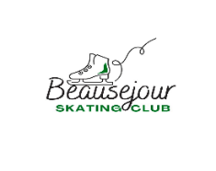

**StarSkate Skater Contract**

Policies for Safety and Sportsmanship

▪ Skaters are representatives of the BSC whether in our arena, away at competitions or online and as such are expected to conduct themselves in a proper and polite manner.

▪ Only members in good standing with the club will be allowed to take part in assessments/ special events. Members not in good standing may be suspend at board's discretion.

▪ All participants have the right to a safe environment both on and off the ice, and as such verbal and or physical abuse of any kind will not be tolerated and could result in immediate suspension.

▪ Parents of skaters are responsible for the behavior of their child during all sessions.

▪ Parents are not allowed on the ice during lessons and are not permitted to remain in the player’s bench or inside the ice pad area. Parents may watch their skater from the stands or through the glass to not interfere with lessons or block access to the ice.

3 STRIKE RULE - If a skater is in violation of the code of conduct as outlined by the StarSkate handbook, they will be:

1. Warned and parents verbally informed.

2. Skater will be warned again with written letters to skater, coach, and parent.

3. Skater will be suspended at the board's discretion (usual minimum 1 month).

If the behavior of a skater is in serious breach of conduct (at board’s discretion) said skater may be immediately suspended **In cases of suspension NO REFUND of any kind will be granted**

Signing the following contract signals both StarSkater and parent/guardian have read the StarSkate Handbook, and agree to abide by its policies.

Signed Skater _________________________________________

Signed Parent _________________________________________ Date ___________________